**Rebel with a Sponsored Cause:**

**External Sponsorship and Rebel Party Transformation**

Elizabeth Brannon and Shane Wery

Ph.D. Students

Department of Political Science

Michigan State University

PLS 900 Networks Analysis

**May 1, 2019**

**Motivation**

What influences the transformation of rebel groups into political parties? In slightly more than half the cases, rebel groups chose to form political parties (Matanock 2018; Manning and Smith 2018). Among the groups that participate in the first post-conflict election, 65 percent will continue to regularly participate and will win at least one seat 90 percent of the time (Manning and Smith 2018). Generally, this transformation and participation tends to be most common in Africa (Soderberg Kavacs and Hatz 2016). The literature on former rebel political parties has established conditions within countries that make this transformation more likely. Matanock (2018) finds that party formation is significantly more likely when the conflict occurred post-Cold War, ended in an intervention, and has third party monitoring in the post-conflict period. The literature has yet to expand this analysis to consider how external factors may also influence rebel party transformation.

We seek to understand how external sponsorship influences rebel to political party transformation. External sponsorship in this paper includes support provided to actors engaged in an internal conflict from an actor that is outside of their country of operation (Saleyhan et al. 2014). Support can come in a number of forms including monetary support, logistics and trainings, troops, intelligence, and weapons. The literature has shown that foreign sponsorship does have a strong influence on the behavior, organization, and survival of rebel organizations in civil conflict (Salehyan et al. 2014; Sinno 2008). The more support a group has—either meaning the more support given by one actor or support by many different actors—the more likely that rebel group is to survive (Sinno 2008). Likewise, groups may have multiple sponsors and they may have sponsors that facilitate inter-rebel alliances, with then intention of strengthens the group even more (Popovic 2018).

Understanding the connections by these two phenomena is important for our understanding for post-conflict stability and peace. The literature generally argues that a key way in which states can help create more durable peace in their societies is to include provisions in peace agreements that allow for rebel groups to transform into political parties and participate in elections (Hartzell and Hoddie 2003; Marshall and Ishiyama 2016; Matanock 2017). The idea is that by doing so, governments give rebels more credible commitments that they will get their share of the pie and the government will not deter them from participating in society and in politics (Manning 2007; Marshall and Ishiyama 2016; Matanock 2016; Themnér 2017). By having a formal avenue through which they can create change and achieve their goals, this should give former rebels less incentive to incite conflict and can lead to a more stable peace.

However, the relationship with foreign sponsors may alter perceptions of costs after conflict for former rebel groups. The support of an external sponsor bolsters the capacity of groups, but also gives groups a safety net. Even if groups have surrendered their weapons at the end of conflict, the relationship with external supporters ensures that procuring new weapons and materials will be easier, if needed. Further, their alliance with external supporters may alter the goals of groups. External supporters may be motivated to manipulate politics via former rebel groups in order to benefit themselves in some way, if they maintain their relationship into the post-conflict environment. External sponsors that are offering support to former rebel groups may end up having significant power over group politics post-conflict. This not only influences the politics of the post-conflict state, but also could mean that groups are working towards goals that are not for the public good, but instead for the benefit of a foreign sponsor. The literature broadly has not addressed how these sponsorship relationships operate in the post-conflict environment. However, if we find that rebel groups with external sponsors are more likely to transform into political parties, it is possible that support networks are still ongoing and may have important consequences for peace prospects post-conflict.

We offer competing hypotheses for the relationship between external sponsors and rebel group to political party transformation. First, it is important to consider the important impacts that external sponsors have on capacity. Given that the literature has shown that rebel groups with external sponsors are more likely to survive and that sponsorship can encourage further alliances, it is quite likely that the more ties a group has, the greater the capacity groups will have. In order for groups to first secure electoral participation provisions in peace agreements, groups need to have enough capacity to have bargaining power during negotiations. Then, in order to be successful in post-conflict elections, groups need resources in order to run winning campaigns, as well as a level of popular support. All of these steps involve a crucial amount of resources and capacity. This leads to our first competing hypothesis:

**Support Hypothesis:** The more sponsorship ties a rebel group has during conflict, the more likely they will be to participate in post-conflict elections.

However, given that sponsorship also often leads to a greater number of alliances with other groups and that actors can have multiple sponsorship relationships, it is possible that groups may have a number of veto players in their decision making process. Groups will be likely to rely on support from these external sponsors a significant degree and thus will at times have their hands tied if their sponsors do not agree with their desired action. Further, at times sponsors may disagree with one another about the proper course of action, restraining further action until an agreement is reached. The more external support ties a group has, the more veto players will also be present. The more veto players in a relationship, the more difficult it may be for groups to take action due to disagreements over goals and tactics. This leads to our second competing hypothesis:

**Veto Players Hypothesis:** The more sponsorship ties a rebel group has during conflict, the less likely they will be to participate in conflict.

**Modeling External Sponsor Relationships with a Network Analysis**

This theory of external sponsorship relationships relies on the assumption that the densities of the network that rebel groups are in matters. Simply indicating the presence of a tie is insufficient, particularly based on the fact that the literature has shown that sponsorship relationships are likely to create further alliances among groups. Therefore, external sponsors are often serving as bridges between groups. Further, these networks also reveal important information about the sponsors themselves. Sponsors may be likely to support more than one group in order to achieve a number of goals. A network analysis allows us to understand which actors are exerting strong influence on global politics by funneling support to many groups.

**The Data**

The data for the analysis comes from two sources: UCDP’s External Sponsorship Dataset and the Militant Group Electoral Participation (MGEP) Dataset. The UCDP data contains observations of external support to actors within conflict from 1975-2009. External supporters are defined as any actor that provides external support and can include a state government, a diaspora, a rebel group, organizations (such as IGOs or NGOs), political parties, companies, lobby groups, or individuals (Högbladh et al. 2011). The dataset includes 10 types of external support: troops, access to territory, access to military or intelligence infrastructure, weapons, materials/logistics, training/expertise, funding/economic support, intelligence material, other forms of support, and unknown support. Our key variable of interest from the dataset is *External Exists*, which is a dichotomous variable that indicates if an actor received any external support (one of the 10 categories defined) from an external sponsor in a given year.

In order to analyze the data in a network, we parse down the data. We include only cases in which a rebel group is the receiver of support, given that we are only interested in rebel group transformation to political parties. We then collapse the *External Exists* variable to a count of the observations of external support that a group received. The majority of the senders are governments, however they are instances of rebel groups both receiving external support and providing external support to other rebel groups.

The MGEP Dataset includes militant and ex-militant group electoral participation from 1970-2010. Militant groups are defined as “non-governmental entities using extra-legal violence to achieve political aims” (Matanock 2018). Matanock’s sample includes both those that are traditionally included as rebel groups or armed actors in conflict datasets, but also those that are typically excluded from these data due to a low number of battle deaths. The two variables of interest from the MGEP Dataset are *Participation* and *Winner*. *Participation* is a dichotomous indicator for if an actor participated in an election in a given year. *Winner* is a dichotomous indicator for whether an actor participated in an election in a given year and won the election. We also collapse this data for the sake of the analysis. We create a dichotomous indicator for if an actor ever participated in a post-conflict election and another for if they ever won a post-conflict election. We choose to collapse our variables due to the time-inconsistency of the data. The UCDP data covers observations that occur during conflict, whereas the MGEP data includes observations that are in the post-conflict period.

The two datasets used names for rebel groups that were often close, but not exact matches, making merging difficult. To account for this, we create a key using fuzzy matching that allows for a match probability. To weed out poor matches, we remove any matches where the probability is less than 0.5, and then spot check from 0.5 and above.

**Network Analysis**

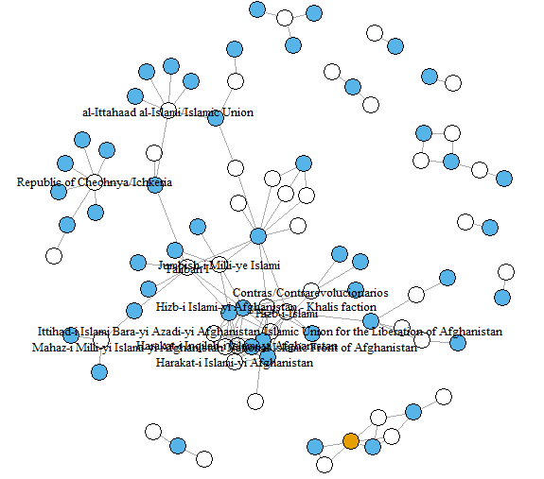 In order to observe the patterns of rebel group funding, we plot the connections between sponsors and rebel groups as a network. In these cases, each node represents either a rebel group or state that acts as a sponsor to a rebel group. This support can manifest as monetary support, providing of arms, or any other tactical assistance. The edges in the networks indicate the presence of any form of support from the state to rebel group. By doing so, we can easily observe rebel groups that receive funding from multiple states as well as states that support several groups.

Figure 1:

Figure 1 offers an introductory look into the layout of rebel sponsorship by identifying sending and receiving groups. In this figure, blue nodes represent funding states while white nodes represent receiving groups. The sole orange dot represents a group that both receives and sends funds, in this case being al-Qaida. At a first glance, it appears that rebel groups are much more likely to receive support from several state actors than states are to support multiple rebel groups. This intuitively makes sense because a rebel group has a particular cause that several states may support for various reasons, but the state has less of an incentive to support a variety of groups with different aims that may or may not align with their goals. More directly put, states are more selective in creating these ties than rebel groups may be, as the rebel group stands to gain more from a diverse set of relationships.

Figure 2 views the same network but is adjusted to examine the success of these groups in participating in post-conflict elections as well as winning said elections. White nodes indicate states that are already in power within their own domain and have no relevance other than as funders. Cyan nodes indicate rebel groups that are funded but are unable or unwilling to participate in elections. Orange nodes represent states that actively participate in post-conflict elections but are unsuccessful in achieving representation. Finally, green nodes are those that are involved in post-conflict elections and are successful at gaining political representation.

From this plot we are able to notice that political participation after conflict appears to be clustered in specific locations, most likely indicating which settings these groups are actually able to participate. In terms of the hypotheses outlined in the sections above, it appears that the veto players hypothesis is better supported by the data. Groups that participate in elections have at most two sponsors, and those that win in these elections have only one source of external sponsorship. In cases where multiple rebel groups participate, they are almost always shared with a common external sponsor. For example, Hezbollah and the Mahdi Army participated in elections with the Iranian government as a shared sponsor as well as shared sponsorship among the participating rebel groups that became Croatia and Bosnia and Herzegovina. The resulting story appears to more about who you know in context to a specific conflict rather than how many people you know. Surprisingly major sponsors from outside regions appear to be less successful in placing sponsored rebel groups in elections, indicated by the cluster including the United States, the United Kingdom, China, and Pakistan with no participating sponsored groups.

Figure 2:

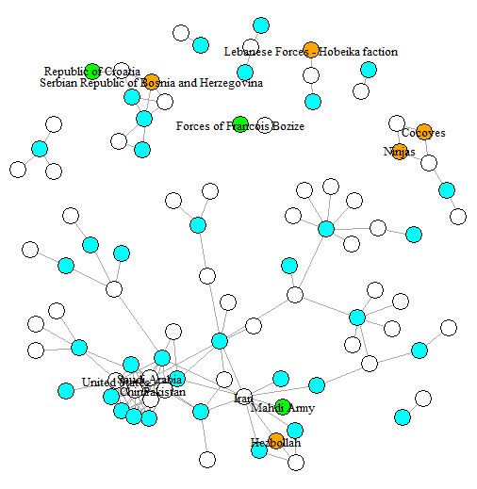

Tables 1 and 2 display the sates that sponsor the most rebel groups and the rebel groups that are sponsored by the most states, respectively. In table 1, the major powers that were discussed earlier as unsuccessful in sponsoring future parties take the top 4 spots on the list. The one case where major senders resulted in political parties is in the case of Yugoslavia, where the rebelling groups were given separate states as the entirety of Yugoslavia was partitioned. It is important to note that with the exception of this unique case, no major rebel group sponsors were able to earn their sponsored rebel groups a spot in governance.

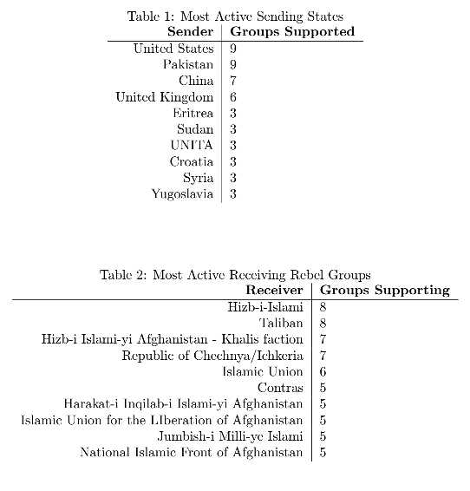

Table 2 gives reason to reject the support hypothesis outlined above. In this case, each of the 10 most sponsored rebel groups did not participate in post-conflict governance. This is especially surprising due to the fact that a large majority of these groups received support from one of the top sending states. This may be due to the increased competition in this high-density portion of the network.

**Conclusion**

While this analysis is introductory and purely descriptive, it uncovered some of the trends in the data that would have been difficult to observe as raw data. Rebel groups that enjoy the most post-conflict success appear to be those that are not tied to large numbers of external state sponsors. On the other hand, states that support several groups do not appear to be producing politically active groups. As we have argued, this may indicate that rebel groups with several funding sources have many veto players that do not allow for the participation in elections.

Next steps in this project include significantly refining the probabilistic matching used to merge the datasets by rebel group as well as incorporating the variation in rebel sponsorship ties over time. Both present clear issues in terms of data management, but the resulting data will allow us to make future empirical analysis more reliable. Additionally, further investigation into rebel groups that are involved in post-conflict governance may allow us to explain the state sponsorship behavior we observe. Finally, if advances in data allow for a measurement of the extent of external support a group receives, we can verify our conclusion that world-power sponsors with larger support to offer are not inherently more effective.

**References**

Hartzell, Caroline and Matthew Hoddie. 2003. “Institutionalizing Peace: Power Sharing and Post-Civil War Conflict Management.” *American Journal of Political Science* 47 (2): 318-32.

Högbladh, Stina, Therése Pettersson, and Lotta Themnér. 2011. “External Support in Armed Conflict 1975-2009—Presenting New Data.” Unpublished manuscript presented at the International Studies Association Convention in Montreal 2011.

Manning, Carrie. 2007. “Party-Building on the Heels of War: El Salvador, Bosnia, Kosovo, and Mozambique.” *Democratization* 14 (2): 253-72.

Manning, Carrie and Ian Smith. 2018. “Electoral Performance by Post-Rebel Parties.” *Government and Opposition*: 1-39.

Marshall, Michael and John Ishiyama. 2016. “Does Political Inclusion of Rebel Parties Promote Peace after Civil Conflict?” *Democratization* 23 (6): 1009-25.

Matanock, Aila M. 2018. “External Engagement: Explaining the Spread of Electoral Participation Provisions in Civil Conflict Settlements.” *International Studies Quarterly* 62 (3): 656–670.

Matanock, Aila M. 2017. “Bullets for Ballots: Electoral Participation Provisions and Enduring Peace after Civil Conflict.” *International Security* 41 (4): 93-132.

Matanock, Aila M. 2016. “Using Violence, Seeking Votes: Introducing the Militant Group Electoral Participation (MGEP) Dataset.” *Journal of Peace Research* 53 (6): 845-853.

Popovic, Milos. 2018. "Inter-Rebel Alliances in the Shadow of Foreign Sponsors." *International Interactions* 44 (4): 749-776.

Salehyan, Idean, David Siroky, and Reed M. Wood. 2014. "External rebel sponsorship and civilian abuse: A principal-agent analysis of wartime atrocities." *International Organization* 68 (3): 633-661.

Sinno, A. H. 2008. *Organizations at War in Afghanistan and Beyond*. Ithaca, NY: Cornell University Press.

Söderberg Kovacs, Mimmi and Sophia Hatz. 2016. “Rebel-to-Party Transformation in Civil War Peace Processes 1975-2011.” *Democratization* 23 (6): 990-1008.

Themnér, Anders, ed. 2017. *Warlord Democrats in Africa: Ex-Military Leaders and Electoral Politics*. Zed Books Ltd.